

**COMMUNITY CONNECT REPORT**

**Course Name:** Connect with Community and Nature

**Course Code:** AOC 101

**Year:** 2nd

**Semester:** 4th

**Session:** 2017-18

**Discipline:** Activity Oriented Course

**Name:** AJINKYA BEDEKAR

**Enrolment Number:** U101116FCS183

***Azadirachta indica***

|  |  |
| --- | --- |
| **Neem** | |
| [Neem (Azadirachta indica) in Hyderabad W IMG 6976.jpg](https://en.wikipedia.org/wiki/File:Neem_(Azadirachta_indica)_in_Hyderabad_W_IMG_6976.jpg) | |
| Flowers and leaves | |
| **Scientific classification** | |
| Kingdom: | Plantae |
| *Clade*: | Angiosperms |
| *Clade*: | Eudicots |
| *Clade*: | Rosids |
| Order: | Sapindales |
| Family: | Meliaceae |
| Genus: | *Azadirachta* |
| Species: | ***A. indica*** |
| **Binomial name** | |
| ***Azadirachta indica*** A.Juss., 1830 | |
| **Synonyms** | |
| * *Azadirachta indica var. minor*Valeton * *Azadirachta indica var. siamensis* Valeton * *Azadirachta indica subsp. vartakii* Kothari, Londhe & N.P.Singh * *Melia azadirachta* L. * *Melia indica* (A. Juss.) Brandis | |

***Azadirachta indica***, commonly known as **neem**, **nimtree** or **Indian lilac**, is a tree in the mahogany family Meliaceae. It is one of two species in the genus *Azadirachta*, and is native to the Indian subcontinent, i.e. India, Nepal, Pakistan, Bangladesh, Sri Lanka, and Maldives. It is typically grown in tropical and semi-tropical regions. Neem trees also grow in islands located in the southern part of Iran. Its fruits and seeds are the source of neem oil.

Description

Neem is a fast-growing tree that can reach a height of 15–20 metres (49–66 ft), and rarely 35–40 metres (115–131 ft). It is evergreen, but in severe drought it may shed most of its leaves or nearly all leaves. The branches are wide and spreading. The fairly dense crown is roundish and may reach a diameter of 15–20 metres (49–66 ft) in old, free-standing specimens. The neem tree is very similar in appearance to its relative, the Chinaberry (*Melia azedarach*).

Etymology

Neem (नीम) is a Hindi noun derived from Sanskrit Nimba (निंब).

Uses

Neem leaves are dried in India and placed in cupboards to prevent insects eating the clothes, and also in tins where rice is stored. Neem leaves are dried and burnt in the tropical regions to keep away mosquitoes. These flowers are also used in many Indian festivals like Ugadi. As an ayurvedic herb, neem is also used in baths.

***Nilgai***

|  |  |
| --- | --- |
| **Nilgai** | |
| [Nilgai (Boselaphus tragocamelus) male.jpg](https://en.wikipedia.org/wiki/File:Nilgai_(Boselaphus_tragocamelus)_male.jpg) | |
| Male at Jamtra, Madhya Pradesh, India | |
| **Conservation status** | |
| https://upload.wikimedia.org/wikipedia/commons/thumb/5/5a/Status_iucn3.1_LC.svg/220px-Status_iucn3.1_LC.svg.png Least Concern (IUCN 3.1) | |
| **Scientific classification** | |
| Kingdom: | Animalia |
| Phylum: | Chordata |
| Class: | Mammalia |
| Order: | Artiodactyla |
| Family: | Bovidae |
| Subfamily: | Bovinae |
| Genus: | *Boselaphus* Blainville, 1816 |
| Species: | ***B. tragocamelus*** |
| **Binomial name** | |
| ***Boselaphus tragocamelus*** (Pallas, 1766) | |
| [Boselaphus tragocamelus map.png](https://en.wikipedia.org/wiki/File:Boselaphus_tragocamelus_map.png) | |
| Range of the nilgai | |
| **Synonyms** | |
| * *Antilope tragocamelus* (Pallas, 1766) * *A. albipes* (Erxleben, 1777) * *A. leucopus* (Zimmermann, 1777) * *A. picta* (Pallas, 1776) * *Boselaphus picta* (de Blainville, 1816) * *B. albipes* (Desmarest, 1816) * *Cemas tragocamelus* (Oken, 1816) * *C. picta* (Oken, 1816) * *Damalis risia* (C. H. Smith, 1827) * *D. picta* (Brookes, 1828) * *Portax risia* (C. H. Smith, 1827) * *P. tragelaphus* (Sundevall, 1846) * *Tragelaphus hippelaphusi*(Ogilby, 1838) | |

The **nilgai** or **blue bull** (literally meaning "blue cow"; *Boselaphus tragocamelus*) is the largest Asian antelope and is endemic to the Indian subcontinent. The sole member of the genus *Boselaphus*, the species was described and given its binomial name by German zoologist Peter Simon Pallas in 1766. The nilgai stands 1–1.5 metres (3.3–4.9 ft) at the shoulder; males weigh 109–288 kilograms (240–635 lb), and the lighter females 100–213 kilograms (220–470 lb). A sturdy thin-legged antelope, the nilgai is characterised by a sloping back, a deep neck with a white patch on the throat, a short crest of hair along the neck terminating in a tuft, and white facial spots. A column of pendant coarse hair hangs from the dewlap ridge below the white patch. Sexual dimorphism is prominent – while females and juveniles are orange to tawny, adult males have a bluish-grey coat. Only males possess horns, 15–24 centimetres (5.9–9.4 in) long.

Etymology

The vernacular name "nilgai" comes from the fusion of the Hindi words *nil* ("blue") and *gai* ("cow"). The word was first recorded in use in 1882. Alternative origins could be from the Persian *gaw* ("cow"). The nilgai has been referred to by a variety of names: neelghae, nilgau, nilgo, nylghau, and nylghai, constructions referring to other "blue" animals. They are also known as white-footed antelope. During Mughal emperor Aurangzeb's reign (1658–1707) of India, the nilgai was known by the name *nilghor* ("nil" for "blue" and "ghor" for "horse").

Threats and conservation

[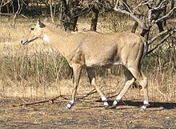](https://en.wikipedia.org/wiki/File:Female_neelgai_1_gir_2006_karthick.jpg)

Nilgai in the Gir National Park, Gujarat (India)

The nilgai is categorised as of Least Concern by the International Union for the Conservation of Nature and Natural resources ([IUCN](https://en.wikipedia.org/wiki/IUCN)). While it is common in India, the nilgai occurs sparsely in Nepal and Pakistan. The major reasons behind its decimation in these two countries and extinction in Bangladesh are rampant hunting, deforestation and habitat degradation in the 20th century.

In India, the nilgai is protected under Schedule III of the Wildlife Protection Act of 1972. Major protected areas for the nilgai across India include: Gir National Park (Gujarat); Bandhavgarh National Park, Borii Wildlife Sanctuary, Kanha National Park, Pachmarhi Biosphere Reserve, Panna Tiger Reserve, Pench Tiger Reserve, Sanjay National Park, Satpura National Park (Madhya Pradesh); Tadoba Andhari Reserve (Maharashtra); Kumbhalgarh Wildlife Sanctuary, Sultanpur National Park in Gurgaon, Ranthambore National Park and Sariska Tiger Reserve (Rajasthan).

Community connect visit

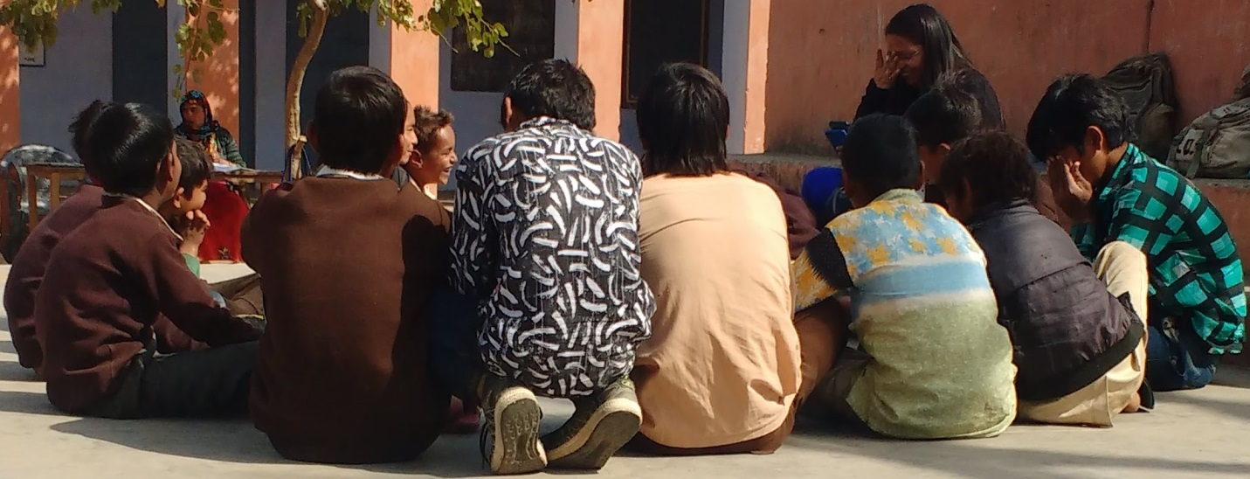

Just after the completion of our Mid Semester I Examinations, the time was to just relax from studies and freshen up mind for the classes that were going to start from Monday. At that awesome Saturday on 17 February 2018, I got a chance to go for my first Community Connect visit to a government school in Majrakath with S3 batch of B. Tech. (1st Year).

On visiting the school, the school was quiet silent with two to three teachers sitting on chairs in the open ground enjoying the heat of sun. Surprisingly, there were just 8-10 students in the school. The teachers were relaxing without any tension of the students’ future if they will not come to study. On asking the reason, they told that regularly, there are very less students who come to school. As soon as we reached the school, the students from First Year Batch took their mentees and started teaching them the lessons that they have prepared to teach through playing games/showing videos. The students of the school were enjoying the teachings and learnt a lot of new things from us.

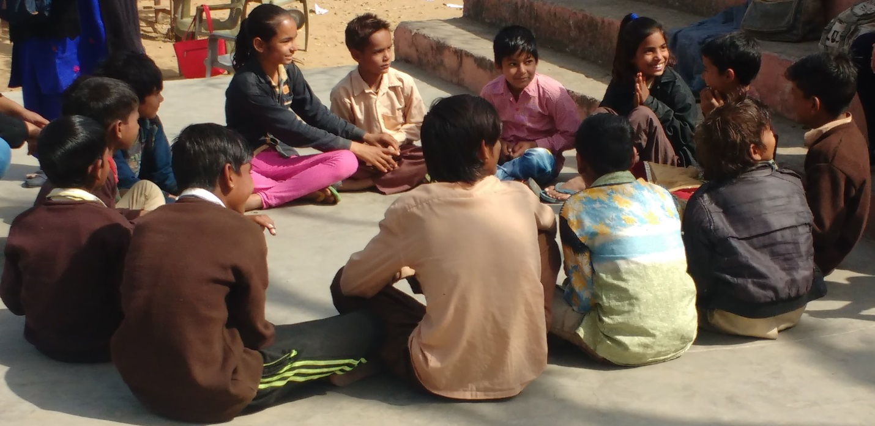

There was a cute and innocent smile on their faces that was showing that they were enjoying to learn and wanted such type of learning daily (provided they are taught by the teachers in such fashion).

One thing that I noted was that the teachers asked the students of the school to do such things which they are not supposed to do, such as brooming a place before sitting. A separate worker must be employed at the school who will clean all the areas of the school regularly. Also, the teachers were very much negligent towards the studies of the students. They just come to school to mark their presence and take salary from the government. Such kind of teachers must be removed from the schools. The education ministry must keep a watch at such schools so that every student who is enrolled in school gets education, and become literate.

When India will become literate then only India will develop.

References: Wikipedia